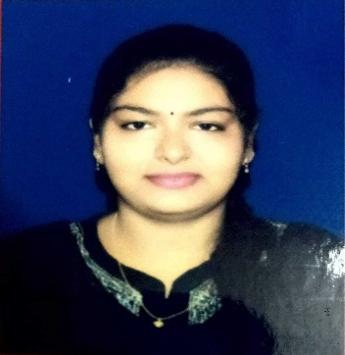
SRADDHA SUMAN MISHRA
Email: sraddhasuman2018@gmail.com
Mobile: +91-8260571871
Address: At-Ishandia, po-gahaga narshingpur, kendrapara, Odisha, 754210

CAREER OBJECTIVE:
- I am seeking opportunities to join a company that can help me in enhancing my skills, strengthening my knowledge, and realising my potential. I am willing to explore a wide variety of opportunities that can help me gain perspective.
EDUCATION:
- MCA: Currently pursuing from Trident Academy of Creative Technology
- Graduation(B.Sc.): Hons. Computer science 2021 with 8.55 CGPA from Kendrapara Autonomous college, Utkal University.
- HSC: Balia Women’s college-2018 with 59.5% Board CHSE.
- SSC: Bharati Vidya Mandir, kajala-2016 with 69.5% Board BSE.
SKILLS:
- Programming Language:
- C
- Core Java
- SQL
- HTML, CSS, JAVASCRIPT(frontend)
- Complete web development course by NIIT foundation.
INTERNSHIP:
- Completed 3 months internship in web development at YHILLS.
HOBBIES:
- Cooking new recipes.
- Exploring and travelling new places.
STRENGTHS:
- Active listening, self-motivated ,communication, problem solving and good team player.
- Honest, hardworking, positive attitude and time management.
- Excellent analytic skills, a creative mind and critical thinking.

